React JS

Javascript is the programing language can manipulate HTML DOM inside the browser only no need to fetch new HTML page on every Request to server.

i.e In modern javascript we can make single page application.

However using Only Javascript to build complex application makes code very complex if we have many things depend on each other on page , so we use React JS which is javascript library to divide page into components and make things simple.

Famous application build using React: Netflix, facebook. Instagram etc..

Anular apps are Gmail, Youtube etc..

Angular has more full packed feature then react e.g routing, however routing in react done by 3rd party package,and angular also uses typescript.

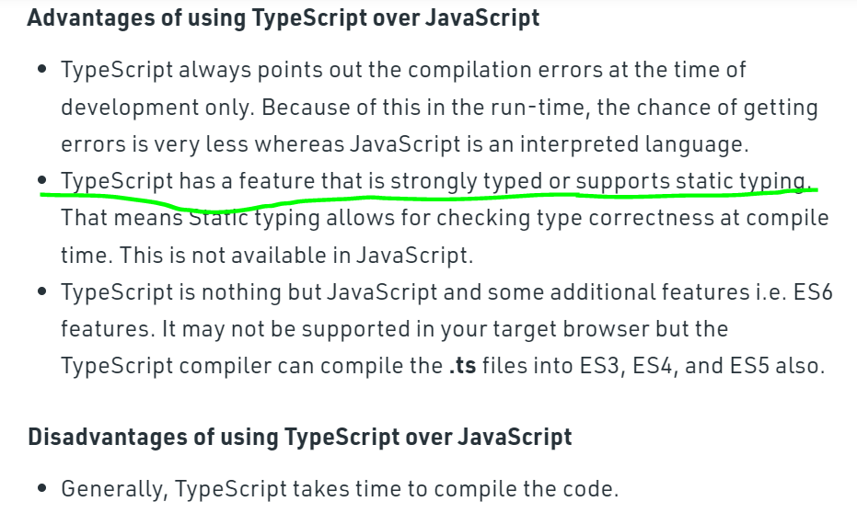

If we had used some wrong data types in code, then only during runtime we need to know that error, but Typescript provide robust Type System to Javascript, so type error will directly show as syntax error before runtime

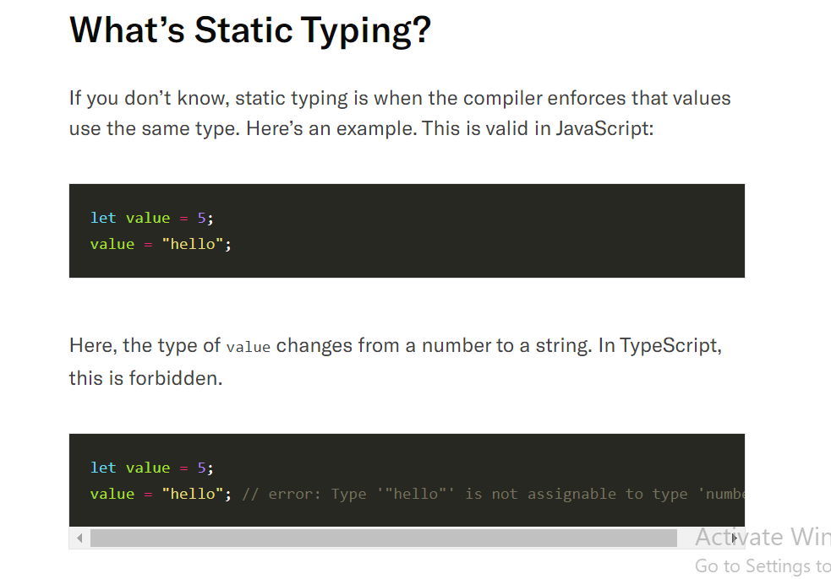

Typescript also have type checking like let a : string, let b: number

The full form of ECMA is European Computer Manufacturer's Association. ECMAScript is a Standard for scripting languages such as JavaScript, JScript, etc. It is a trademark scripting language specification. JavaScript is a language based on ECMAScript.

Vue Js is the mixture of Reactjs and angular

COMPONNTS: components are the one which are used multiple times on page, I.e resuable building blocks.

Components = html+css+Javascript.

Component are the just the Javascript function which can return HTML

To run react default app use : npx create-react-app Appname to automatic create create app structure and then run npm install and npm start

JSX = javascript + HTML, However this javascript with html code will transformed into Javascript by the browser and then it will render the page.

React function component must return only 1 html element

Props:

Props are the attribute of the Custom Html elements which can pass to corresponsing component function as parameter.

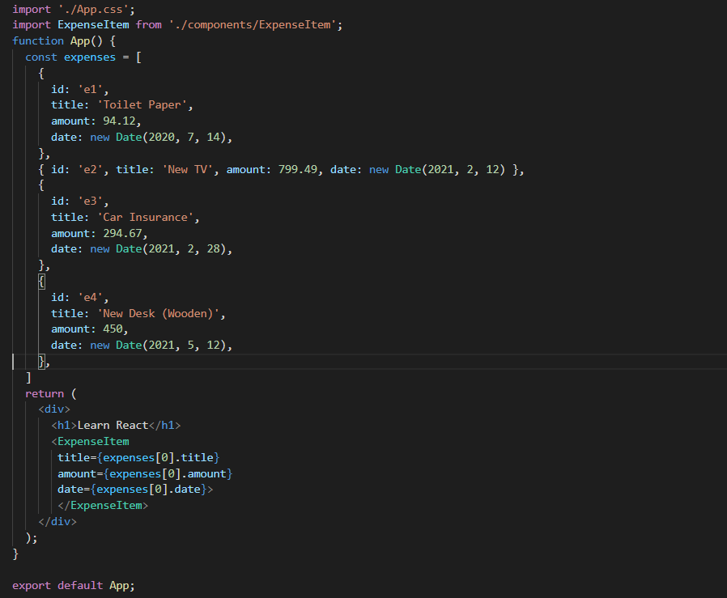

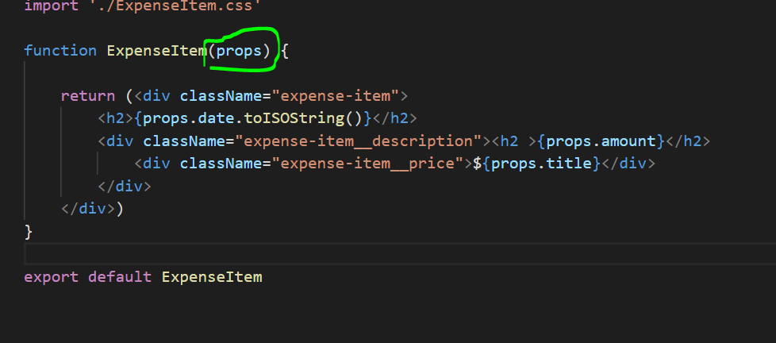

<ExpenseItem></ExpenseItem> this component can also be written as self closing tag <ExpenseItem/>

Its not necessary to

import React from 'react';

in every js file but behind the scene every function return something like this

which uses react library only

for e.g :

function fun(){

return React.createElement(‘div’,{attribute of div},{child element of div })

}

HTML PAGE CONTENT:

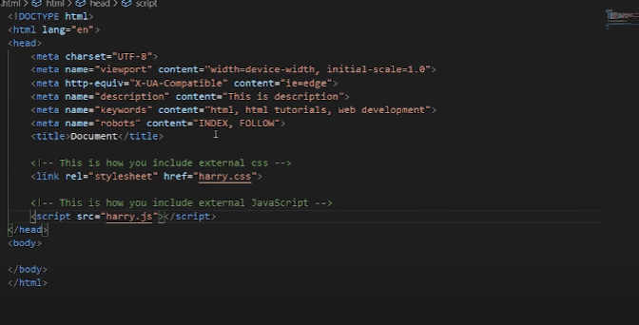

Charset=”UTF-8”: Specifies the character encoding for the HTML document

All HTML documents must start with a <!DOCTYPE HTML> declaration.

The declaration is not an HTML tag. It is an "information" to the browser about what document type to expect.

The lang attribute specifies the language of the element's content.

Common examples are "en" for English, "es" for Spanish, "fr" for French and so on.

<meta > tag is used to rank your page in search engine optimization and also help to give meta(additional information)

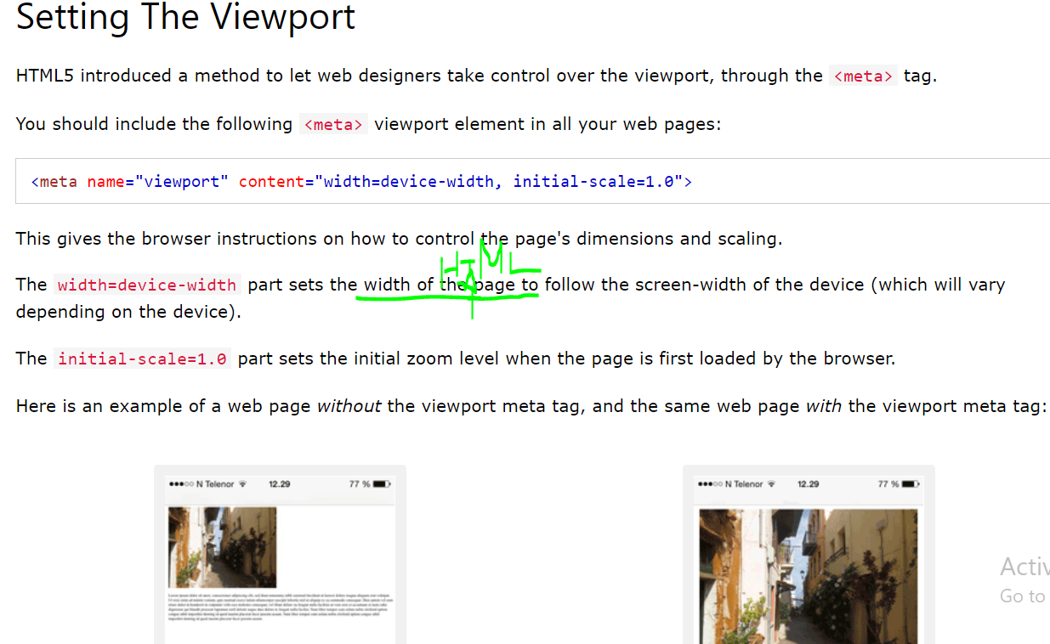

Viewport: adjust site to device viewport

Inside meta tag ,also some attributes are

name=”keywords ” content=”html webdevelopment etc”: this content will match with google search text to optimize search result.

name=”robot” content=”INDEX FOLLOW” : this will tell the webpage to index this page in search result

name=”description” content=”any description” : this will be the description content which shows below of main link on search.

<pre> this tag will display space like this

And

new line in html page </pre>

<aside> this tag is used to display Adds in our webpage </aside>

<iframe> this tag is used to display other website inside our website</iframe>

<sup> superscript like 2n </sup>

<sub>subscript like H2O</sub>

STATE:

When Whole react page is loaded all component function get already executed so any event after on respective component would not run component again so we need to use state to tell component something change so re-render the component.

In order to tell component that something is changed we use react hook i.e useState, this make the special variable.

However useState hook only be called inside component function.

useState function returns an array with having currentState and function to update currentState.

const ExpenseItem = (props) => {

  const [title, setTitle] = useState(props.title)

  const clickHandler = ()=>{

    console.log("cliked!!!");

    setTitle('Updated!!')

  }

  return (

    <Card classNamchilde='expense-item'>

      <ExpenseDate date={props.date} />

      <div className='expense-item__description'>

        <h2>{title}</h2>

If your latest state depends on previous state then use arrow function like this..

setUserInput ((prevState)=>

return { ...prevState, enteredTitle: event.target.value };

});

Arrow function is recommended because state does not change instantly but it schedules the state change, so when multiple state change occurs simultaneously arrow function will gurentee the state changes in sequences as like asynchronous task analogy. This used when setting new state belong to same state not depend on some another State.

To achieve two way binding

const [enteredTitle, setEnteredTitle] = useState('');

    const onTitleChangeHandler = (event)=>{

        setEnteredTitle(event.target.value);

    }

 <input type='text' onChange={onTitleChangeHandler} />

**<p>{enteredTitle}</p>**

To pass Data From parents to child -> use props

To pass Data from child to parents -> pass function of parent as a prop to child and execute .

To pass data between Sibling Component -> then it’s a combination of above two, pass data from 1 sibling to the parents of both siblings, the pass data parent to another Sibling.

Looping element in JSX : use map function:

      <Card className="expenses">

    <ExpenseFilter selected={filteredYear} onSelectYear = {selectYearHandler}/>

    {props.items.map( expense =>

         <ExpenseItem

            key={expense.id}  //Note: to render array we need to add

                                    //key to tell react how to render exactly

            title={expense.title}

            amount={expense.amount}

            date={expense.date}

       /> )}

    </Card>

To render data Conditionally:

    let expenseContent = <div className='new-expense'>

                        <button onClick={showFormHandler}>Add New Expenses</button>

                        </div>

    if(showExpesneForm){

        expenseContent = <ExpenseForm cancelExenpseForm={cancelFormHandler} onSaveExpenseData={SaveExpenseDataHandler} />

    }

    return (

        <div className='new-expense'>

                {expenseContent}

        </div>

    )

// Note u cannot use block type condition like if(){} or for(..){} inside jsx , u can only use 1 line expression like ternary for conditioning OR map for loop

OR

Return(

{condition ? (<html/>): <html/> } OR

{condition && ( trueish <html/>) }

)

Dynamic Styling:

const ChartBar = (props)=>{

    let barFillheight = '0%';

    if(props.value>0){

        barFillheight = Math.round( (props.value / props.maxvalue * 100) ) + '%'

    }

    return(

        <div className='chart-bar'>

        <div className='chart-bar_inner'>

          <div className='chart-bar_fill' ***style={{height:barFillheight}}></***div>

        </div>

        <div className='chart-bar_label'>{props.label}</div>

       </div>

    )

}

Normally in react styling are globally scopped, so in order to prevent that 1 component styled clash with other component styled when having same Name.

We use CSS Module-> so styles get component scoped only.

Rename -> .css file to .module.css

Use className={style.classname}

Is classname content ‘-‘ then use className={style[‘form-control]}

**New Concept**

In order to prevent extra div to render inside DOM we use wrapper function, so we wrap return JSX of compenent inside wrapper instead of unnecessary div’s. ,as this Custom Component only render its children inside DOM.

const Wrapper =()=>{

return props.children;

}

export default Wrapper;

Instead of creating this wrapper by own react provides built In wrapper known as React.Fragment

You can wrap your JSX inside

<React.Fragment>< React.Fragment/> OR inside

<> </>

React Portals: technically Something like PopUp window, SideDrawer this thing need to be Rended on top of the DOM not deep inside some elements, so we can port that html position to somewhere else using react Portals.

Mark the Position where u have to render that particular element/component like

Inside index.html add

<div id=”'backdrop-root”></div>

const Backdrop = (props)=>{

return <div className={classes.backdrop) onClick={props.onConfirm) />;

}

const ErrorModal = (props) => {

return (

<React.Fragment>

{ReactDOM.createPortal(

<Backdrop onConfirm={props.onConfirm} />,

document.getElementById ('backdrop-root')

)}

</React. Fragment>

);

Ref: ref hook use to connect Input html with javascript Code as shown below.

useRef hook always return inputNode Object

const nameInputRef = useRef(); //refHook

const ageInputRef = useRef();

// to get value from Input:

const enteredName = nameInputRef.current.value;

const enteredAge = ageInputRef.current.value;

JSX

<input

id="username"

type="text"

ref={nameInputRef)

/>

<label htmlFor="age">Age (Years)</label>

<input

id="age"

type="number"

ref={ageInputRef}

/>

//note this ref only work on defaultHtml not on custom component

To use ref in custom component we use ForwardRef.

**New Concept**

Side effects and Effects are same.

Side effects use to manage asynchronous task like http req, data coming from props,Timers, and storing data in browser etc..

Managing this asynchronous task inside function directly will lead to infinite loop because if http response change some state then whole component will re-render and again http req will be sent and goes into infinite loop.

We use useEffect hook for this purpose.

3 ways to use useEffect :

1. useEffect(()=>{}) // takes 1 argument then it will run on every state changes, but it will prevent infinite loop as it will not execute state initialization line again.it will run on every render

2. useEffect(()=>{},[])// takes two arguments anonymous arrow function and empty dependency array and here useEffect will Run only once. If we need to run useEffect only once.because on every render [] will be same.

3.useEffect(()=>{}, [dependency]) // takes two arguments anonymous arrow function and dependency array and useEffect Run when dependency Changed.

  function App() {

  const [isLoggedIn, setIsLoggedIn] = useState(false);

**const storedUserLoggedInInformation = localStorage.getItem('isLoggedIn');**

**useEffect(()=>{**

**if(storedUserLoggedInInformation){**

**setIsLoggedIn(true);**

**}**

**},[])**

  const loginHandler = (email, password) => {

    // We should of course check email and password

    // But it's just a dummy/ demo anyways

    localStorage.setItem('isLoggedIn','1')

    setIsLoggedIn(true);

  };

  const logoutHandler = () => {

    localStorage.setItem('isLoggedIn','1')

    setIsLoggedIn(false);

  };

When the app runs first Time , useEffect Function will run after the component get render, so as we know when some state gets changed then whole component rerender so 1st line of code where we initialize state i.e isLogin = false,then setIslogin run again then it will goes into infinite loop.

So in order to prevent whole component rerender on some state changes and only specific function logic to execute, we write that specific logic inside useEffect hook, so that particular logic runs instead of whole component logic on state changes.

This will also prevent infinite loop.

when component re-render on refresh then dependency does not change then component will not rerender.

Use return inside useEffect to execute some cleanup function

Before component unmount.(Note: this return code will run first before the code inside useEffect function)

useReducer Hook :

when you update the state which depends on another state and when u have multiple state update which may related to each other, there we can use useReducer hook.

Const [state,dispatchFnc]= useReducer(reducerFnc, initialState, initalFunc)

This reducerFnc will consume the the latest state snapshot and despatchFnc will return the new updated state.

  const [passwordState,dispatchPassword] = useReducer(passwordReducer,{value:'',isValid:null});

const emailReducer = (state,action)=>{

  if(action.type === "USER_INPUT"){

    return {value:action.val, isValid:action.val.includes('@')}

  }

  if(action.type === "INPUT_BLUR"){

    return {value:state.value, isValid:state.value.includes('@')}

  }

  return {value:'',isValid:false}

}

  const emailChangeHandler = (event) => {

    dispatchEmail({type:"USER_INPUT",val:event.target.value})

    // setFormIsValid(passwordState.isValid && emailState.isValid)

  };

React Context:

When u need to send props from 1 component to another component which are very far from each other, so we have to send prop through various chain of compenent where that prop is unused, so in order to send prop to destination component directly we use React Context.

To use context we need to create a context in another file where we can store props data

e.g

import React from 'react';

//create context

const AuthContext = React.createContext ({

isLoggedIn: false

});

export default AuthContext;

to use context we have to 1st wrap context and consume context

//wrapping context

<AuthContext.Provider

value={isLoggedIn: false}

… other component where we using props

/>

//consuming context using useContext hook in targeted component

Const ctx = useContext(AuthContext);

Access context value as “ctx.value” inside component JSX

Limitation of context:

If your state changes every millisecond or second then context is not ideal for usage so instead of that we use Redux.

Rules of React Hook:

1. Use React hook only inside the react Component function and inside react Hooks only.
2. Don’t call any react hook inside any nested function or any blocks statements like if(){} or for(..){}

 For Passing Parameters for function we use bind Method

const CartItemRemoveHandler = (id)=>{

  }

  const CartItemAddHandler =(item)=>{

  }

  const cartItems = (<ul className={classes['cart-items']}>

     {ctx.items.map((item) => (

        <CartItem name={item.name} amount={item.amount} price={item.price}

          onRemove={CartItemRemoveHandler.bind(null,item.id)}

          onAdd={CartItemAddHandler.bind(null,item)}>

          </CartItem>

  ))}

Some Optimization techniques of react app

Virtual Dom is the blue print of Actual DOM, when some component change it will render Whole Virtual Dom Again,so now Virtual DOM will compare with Actual Dom and those component change will only get updated in actual DOM.

Function component reevaluated when some props or some state changed but it will not re-render the whole DOM.

When parent component reevaluated then child component also get reevaluated

So every child component also get reExecuted even its props and state not changed so it cost performance.

So in order to avoid that we use React.memo().

e.g const componentName= ()=>{

//….

return

}

Export default React.memo(componentName)

Note React.memo compare the previous state with current state props, so for props like reference type(e.g functions here)it will not work, it work only for primitive type.

So in order to make React.memo work,we use useCallback hook.

useCallback will make new function in the memory.

Like without useCallback func1 === func1 -> false.

Using useCallback func1 === func1 -> true.

function App() {

const (showParagraph, setShowParagraph] = useState(false);

console. log('APP RUNNING');

const toggleParagraphHandler = useCallback(() => {

setShowParagraph((prevShowParagraph) = !prevShowParagraph);

}, []);

return (

<div className="app">

<h1>Hi there!</hl>

<Demooutput show=(false} />

<Button onClick={toggleParagraphHandler)>Toggle Paragraph!</Button>

</div>

) ;

To prevent some performance Intensive task like sorting on everytime component function reevaluated we use useMemo() hook

const sortedList = useMemo (() => {

console. log('Items sorted');

return items.sort((a, b) = a - b);

}, [items]); |1

console. log('DemoList RUNNING');

Class Based Component:

Note: in class based component react hooks does not work

import { Component } from 'react';

import classes from './User.module.css';

class User extends Component {

render() {

return <li className={classes.user}>{this.props.name}</li>;

}

}

//props are automatically passed in render function , and u access with this keyword

class Users extends Component {

constructor() {

super();

this.state = {

showUsers: true,

more: 'Test',

};

tóggleUsersHand Ler() L

// this.state.showUsers = false; // NOT!

this.setState((curState) => {

return { showUsers: !curState.showUsers };

});

return (

<div className={classes.users}>

<button onClick={this.toggleUsersHandler.bind(this)}>

{this.state. showUsers ?'Hide' : 'Show'} Users

</button>

this.state.showUsers && usersList

</div>

);

In class based component there is concept of lifeCycles

however in functional component there is useEffect hook.

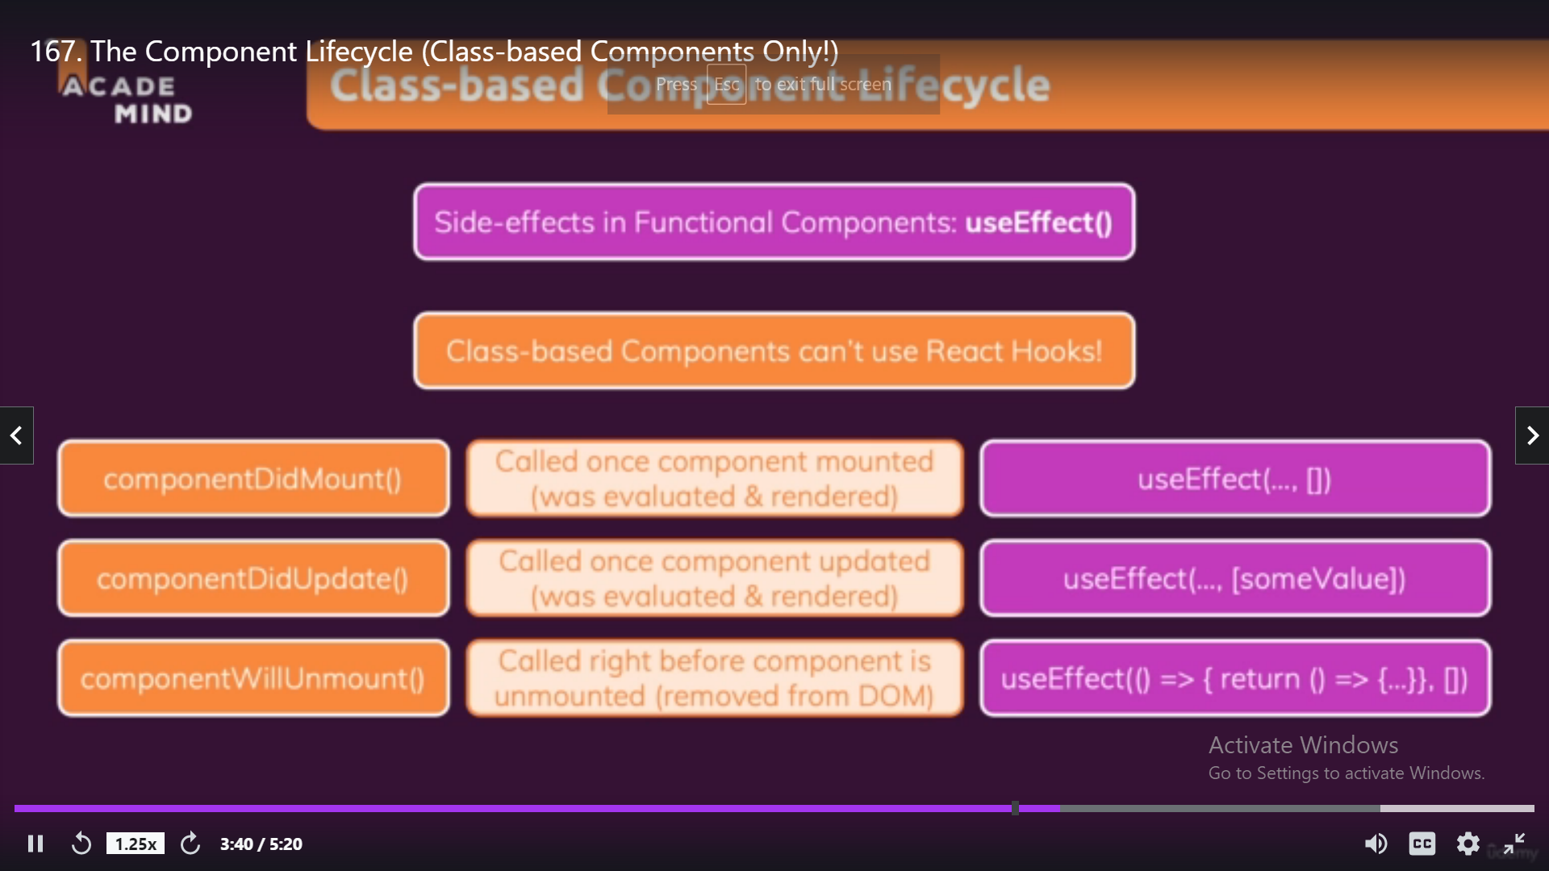

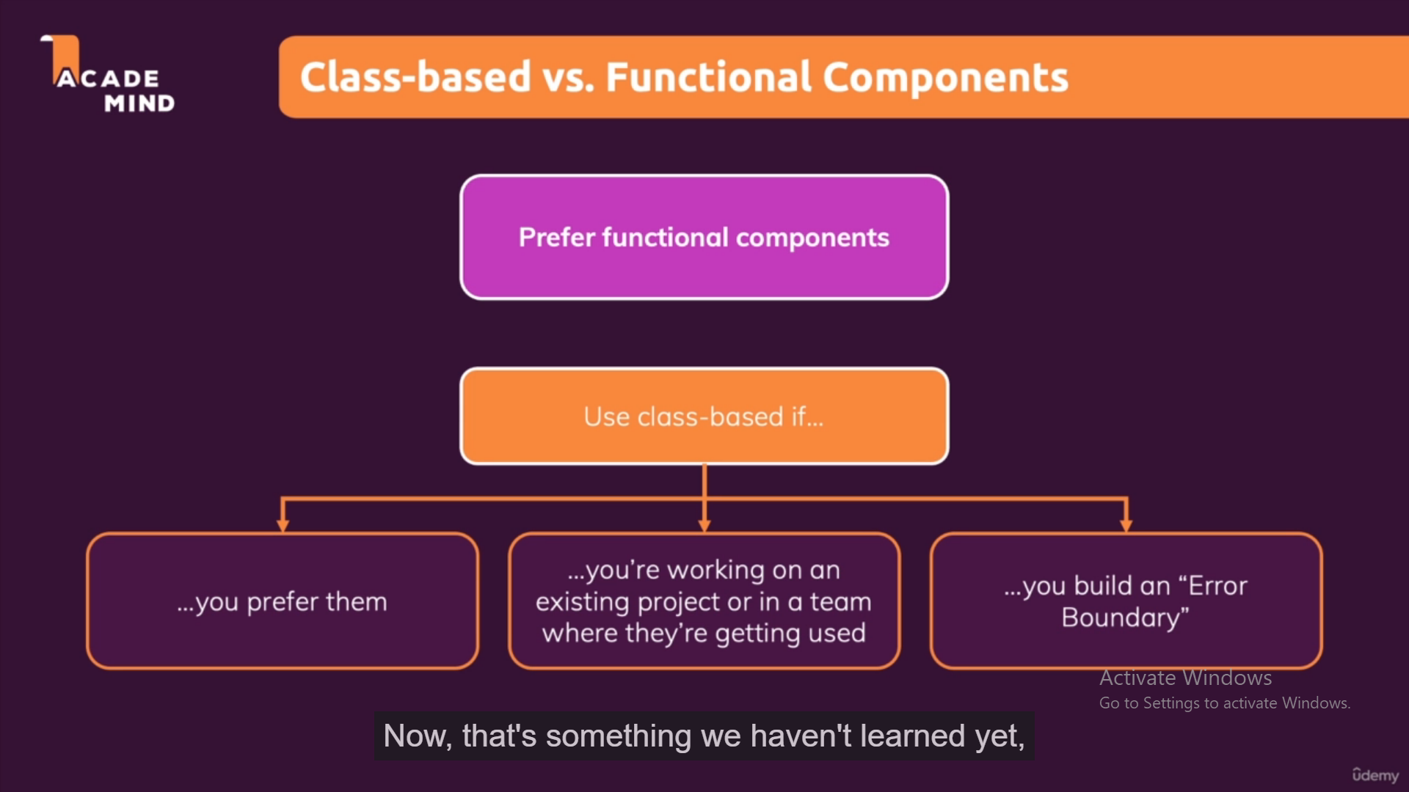

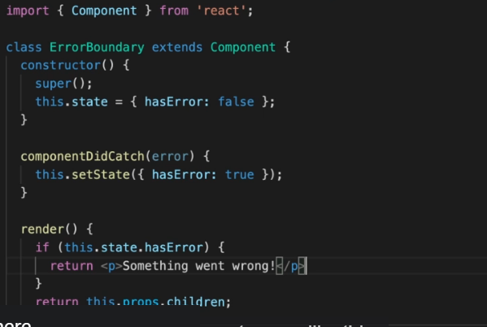

Sending Http request in react:

1. Get request

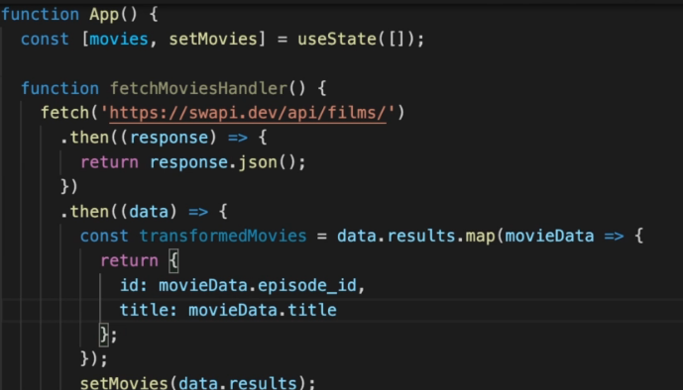

We use fetch(“api link”) for http request this is an

asynchronous task so it will return promise.

There is another 3rd party package known as axios which also have ability to treat error for http status code.

Note: http req return json as data so to convert json

into javacript object we must use response.json().

1. Post request

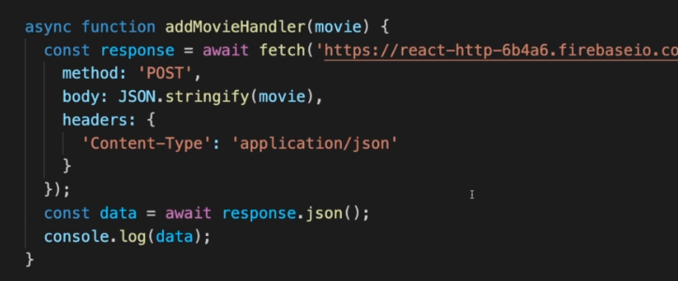

And fetch(“api”,{method=’POST’}) also used for post request also.

And inside post request we don’t send javascript object but we send in JSON format so we convert javascript object into JSON using JSON.stringify(javascript Obj)

*Custom Hooks:*

Custom hooks are regular javascript function with the special things that in this custom hook you can use react hooks also.

i.e outsource statefull logic as re-usable function.

Custom hooks will prevent code duplication.

The state which you use in custom hook will tied to component where you called this custom hook.

Creating custom hook:

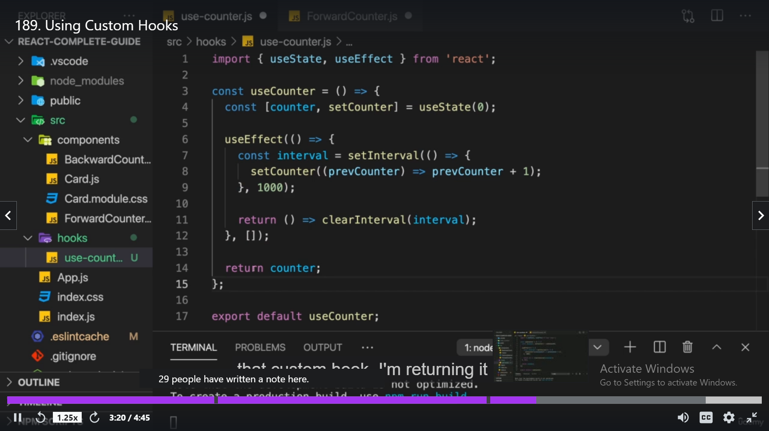

Using custom hook:

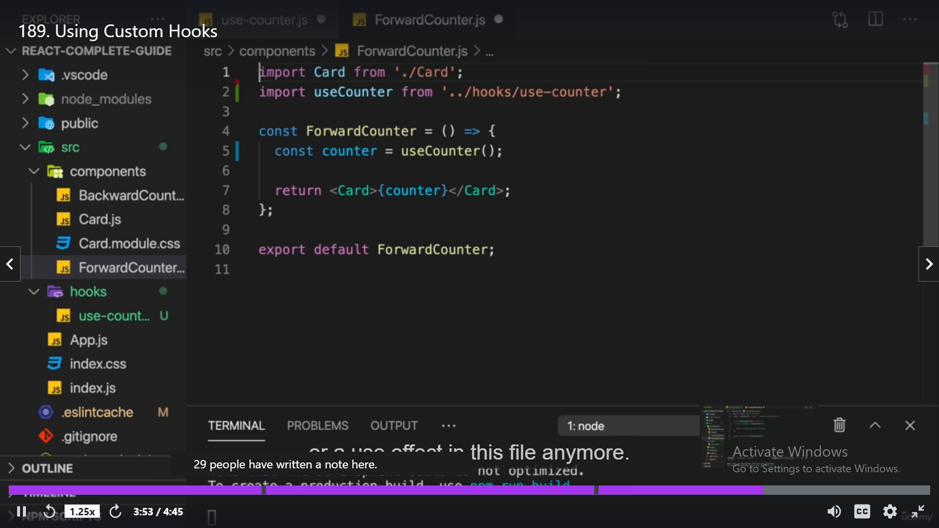

Redux :

Redux help to manage app wide state.

Disadvantages of context:

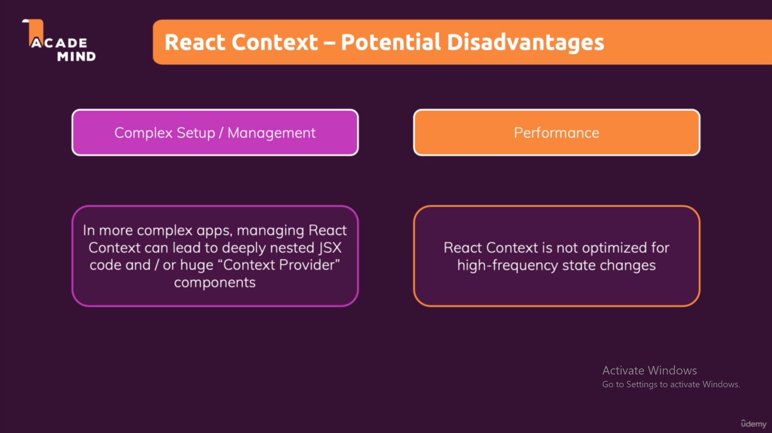

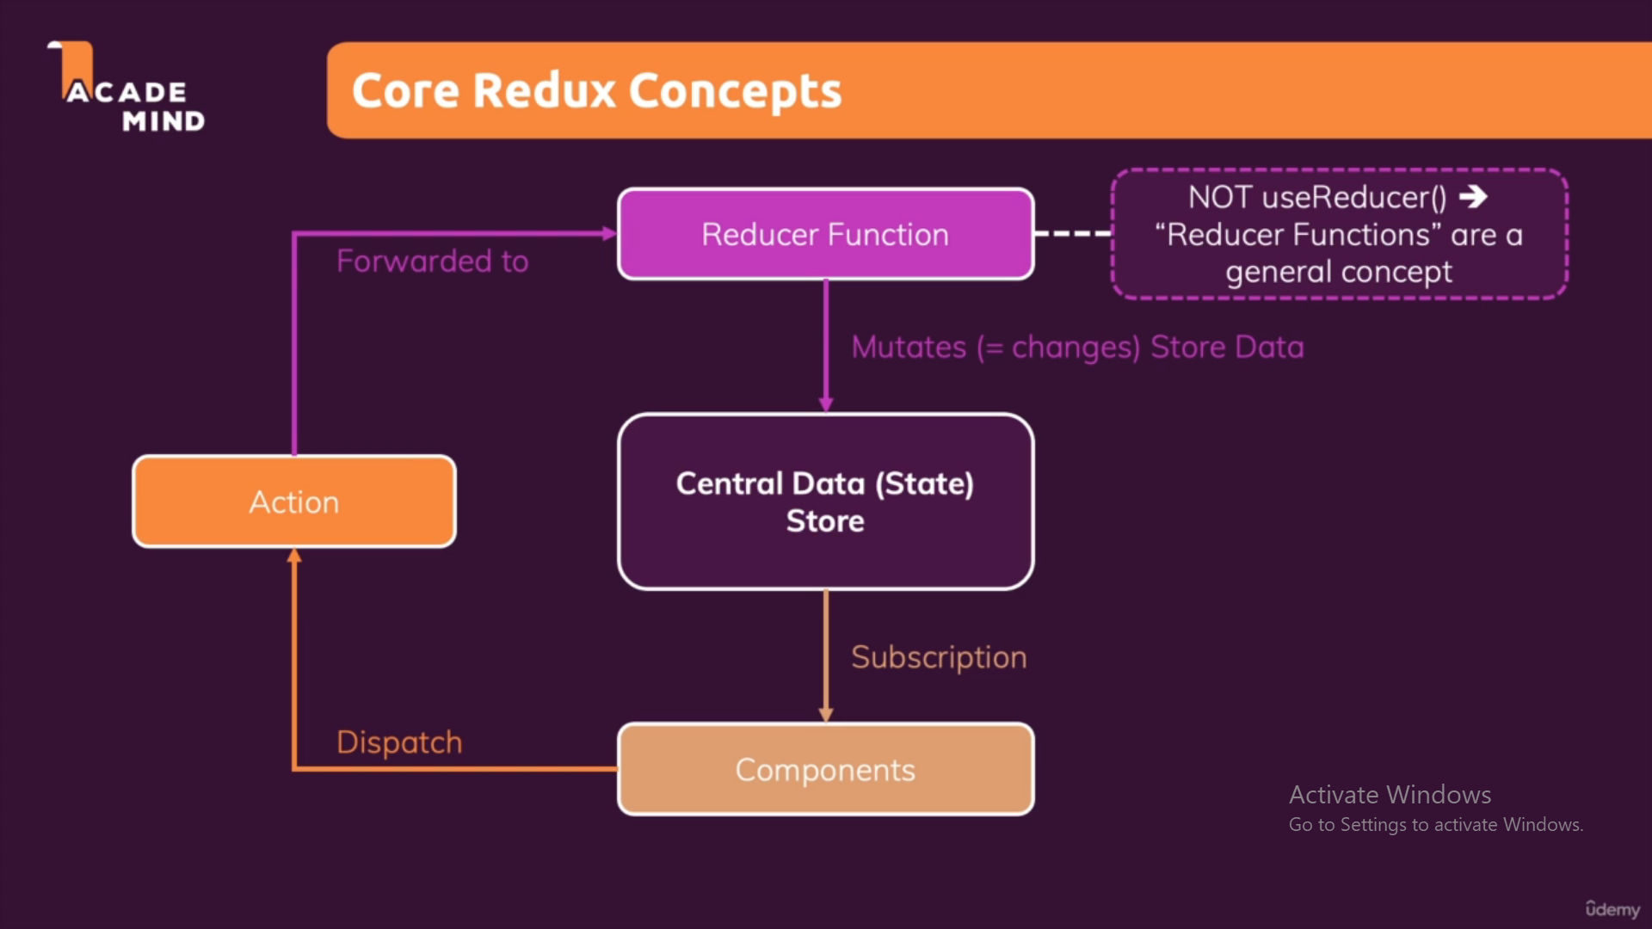

Creating redux store:

import {createStore }from 'redux'

const reducerFunc=(state={counter:0},action)=>{

    if(action.type==='INCREMENT'){

        return {counter:state.couner+1 } // Always return brand new Object ,never mutate state like this state.counter++

    }

    if(action.type==='DECREMENT'){

        return {counter:state.counter-1}

    }

    return state

}

const store = CreateStore(reducerFunc)

store.dispatch({type:'INCREMENT'})

store.dispatch({type:'DECREMENT'})

export default store

Providing redux store to component

import {Provider} from 'redux'

import store from './store/index'

ReactDOM.render(<Provider store={store}><App /></Provider>,

    document.getElementById('root'));

getting particular state value from store using useSelector()

import { useSelector } from 'react-redux';

const Counter = () => {

  const toggleCounterHandler = () => {};

  // useSelector automatically manages subscription for getting specific state value from store

  const counter = useSelector(state=>state.counter)

using Dispatch Function to update the state in the store

import { useSelector ,useDispatch} from 'react-redux';

const Counter = () => {

  const toggleCounterHandler = () => {};

  const dispatch = useDispatch()

  // useSelector automatically manages subscription for getting specific state value from store

  const counter = useSelector(state => state.counter);

  const IncrementHandler =()=>{

    dispatch({type:'INCREMENT'})

  }

  const DecrementHandler = ()=>{

    dispatch({type:'DECREMENT'})

  }

We can Manage Redux store More efficiently using Redux Toolkit:

npm install @reduxjs/toolkit

import {createStore } from 'redux'

import { createSlice ,configureStore} from '@reduxjs/toolkit'

const initialState = {counter:0, showCounter:true}

const counterSlice = createSlice({

    name:'counter',

    initialState,   // this means initialState:initialState javascript shortcut

    reducers:{

        increment(state){

            state.counter++

        },

        decrement(state){

            state.counter--

        },

        increase(state,action){

            state.counter = state.counter + action.payload  //action.payload is the paramenter which we pass inside the function

        },

        toggler(state){

            state.showCounter=!state.showCounter

        }

    }

})

const store = configureStore({

    reducer: counterSlice

})

export const counterActions = counterSlice.actions;

export default store

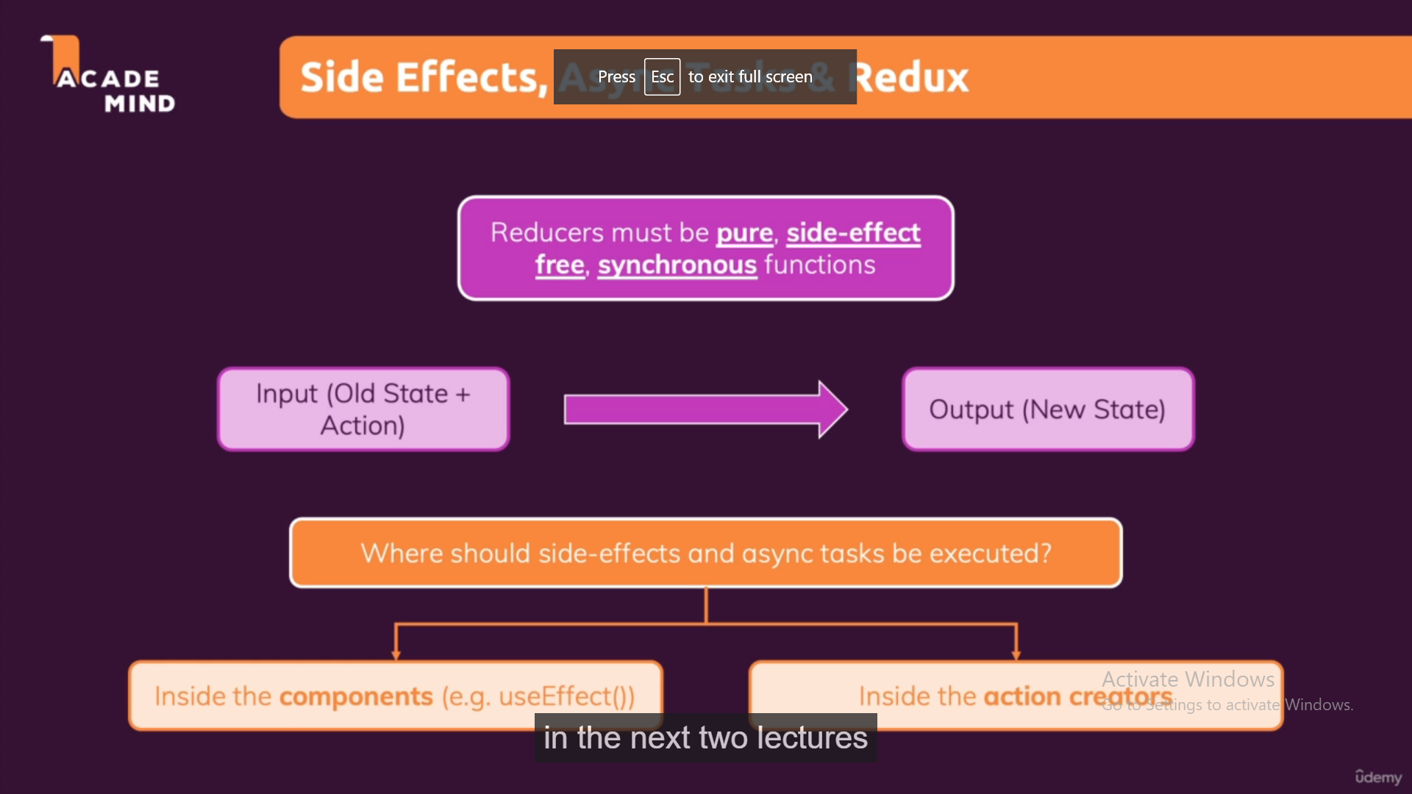

Note: You cannot write SideEffect/Asynchronous Code inside Reducer Function

So to achieve this we write this we write SideEffect/Asynchronous Code inside useEffect Function OR we use Action Creator THUNK i.e dispatching Function that include SideEffects code itself.

To debug Redux Store easily use Redux DevTool Chrome Extension.

React Router

Version 5:

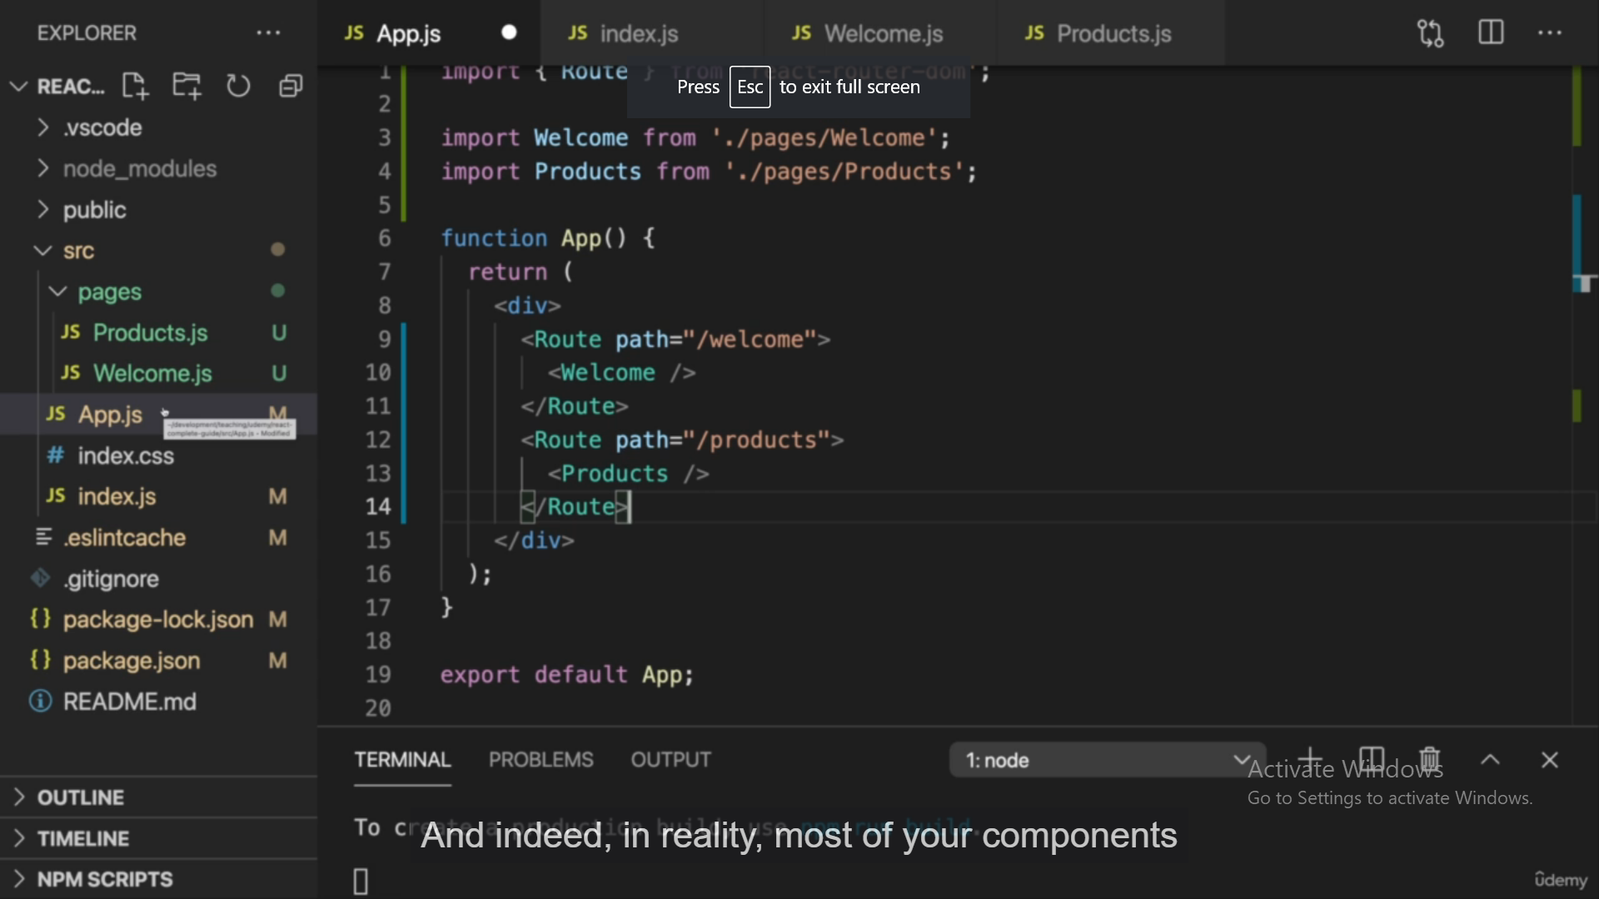

To activate React router we have to wrap our App component using <BrowserRouter>

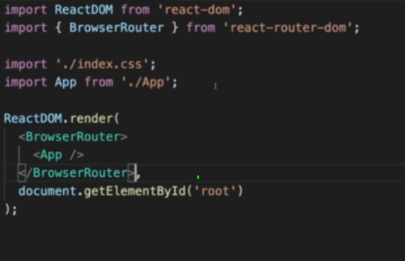

If Any path does not match your route then it should treated as wild card route

i.e *

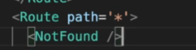

Programatic Navigation:

We use useHistory hook to navigate programitically. Which track history of pages.

Two methods:

History.push(‘/path’)-> this will add new page to history of page stacks and allow to go back using back button.

History.replace(‘/path’) - > this will replace the current page with specific route component and does not allow to go back.

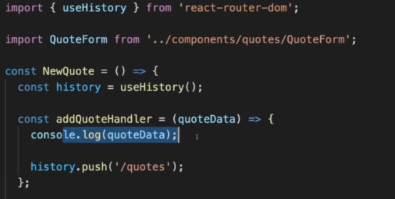

We can use Prompt to show warning on accidently changing the page(specially forms page)

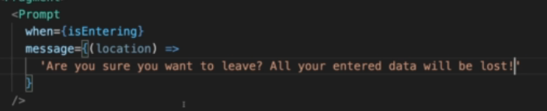

Routing using Link

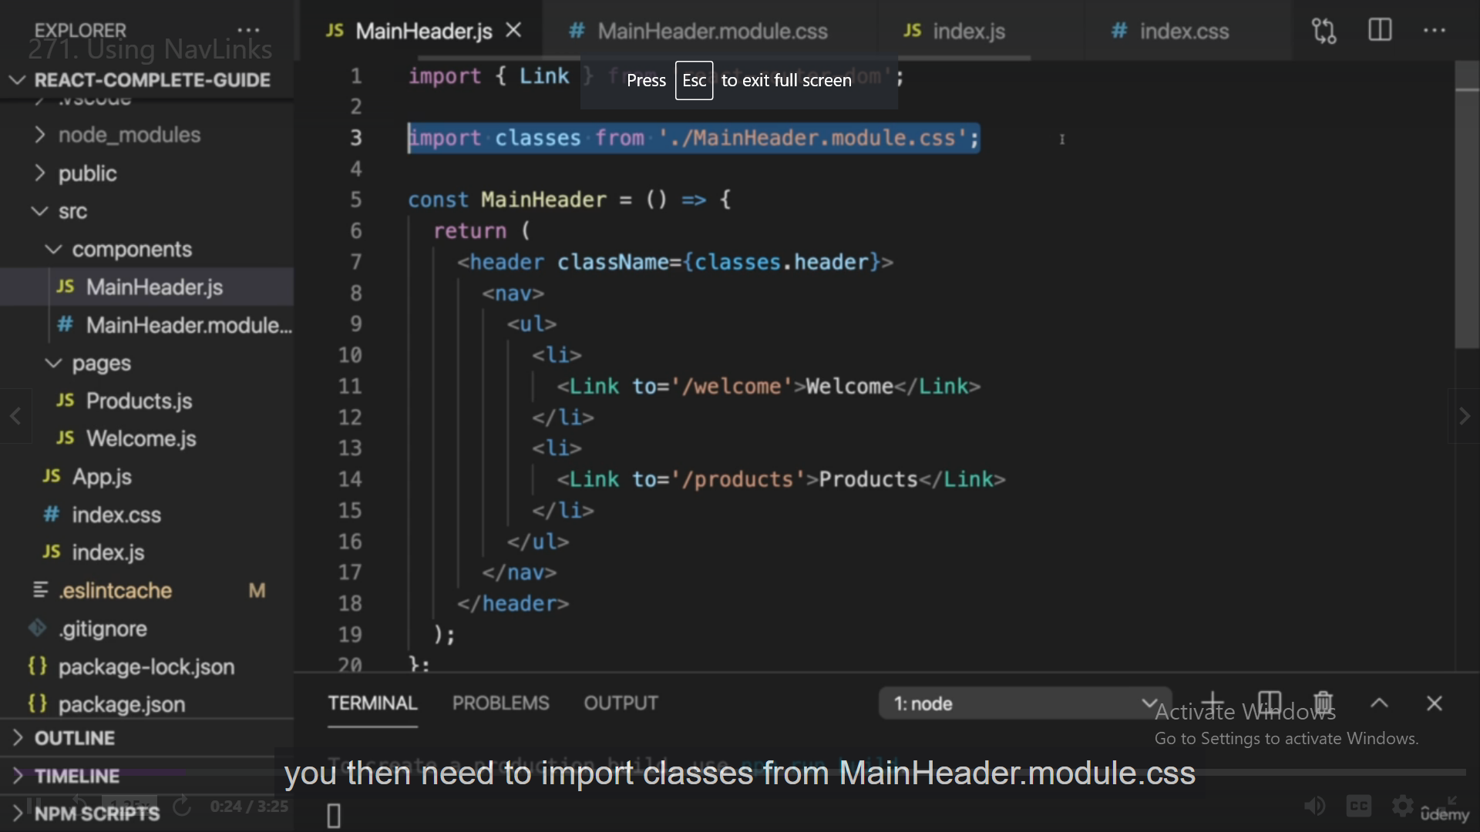

<NavLink> is used to add active CSS class wt highlight selected Link.

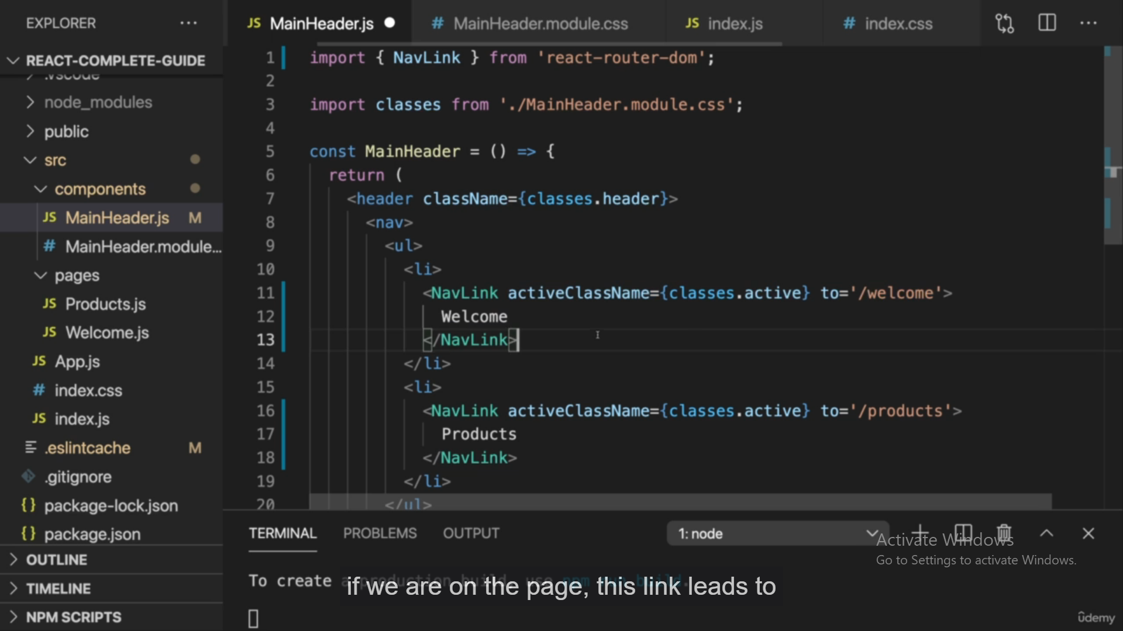

Dynamic Route:

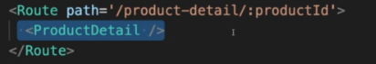

FGetting Access of dynamic route using Params:

Current route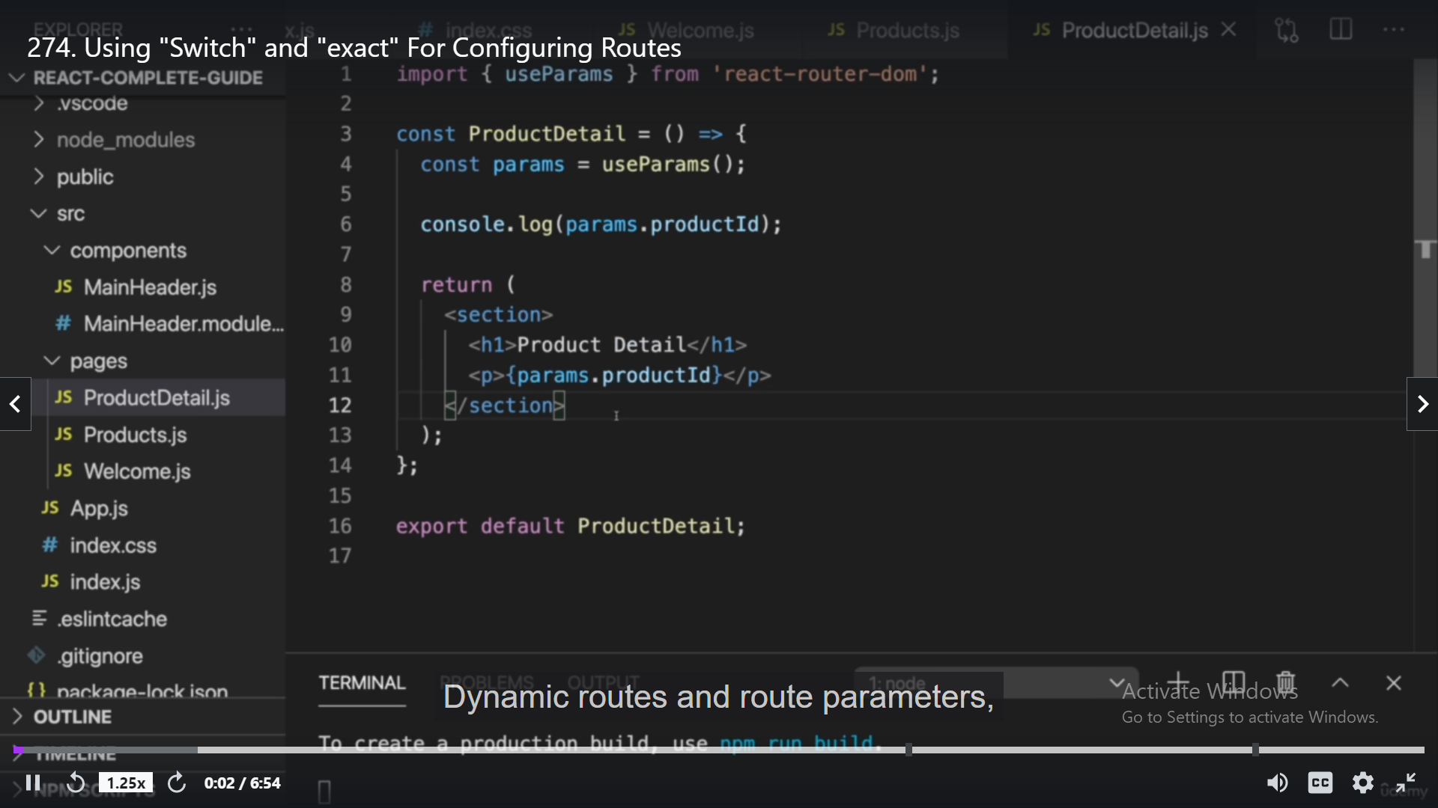

Rendering only particular component with specific route using surrounding router by switch and exact keyword:

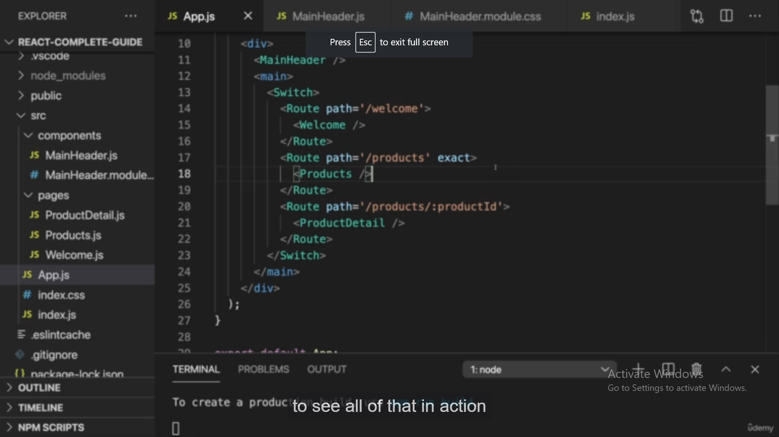

Redirect to some route on visiting particular route using <Redirect to=’/any router’ />

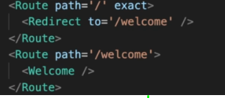

Getting current route using useLocation()

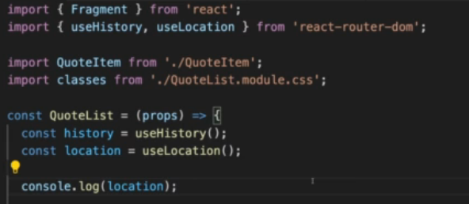

useRouteMatch() also can be used in place of useLocation(), wic also give additional information about route.

React route Version 6:

In version 6 we use <Route> instead of Switch and use element={ component Name} to render respective element w.r.t route.

Version6 doesnot required any order of routes, it automatically render best route which called.

It also not required exact keyword to match exact route, it automatically does.

To match only start of route we use path=’/*’ .

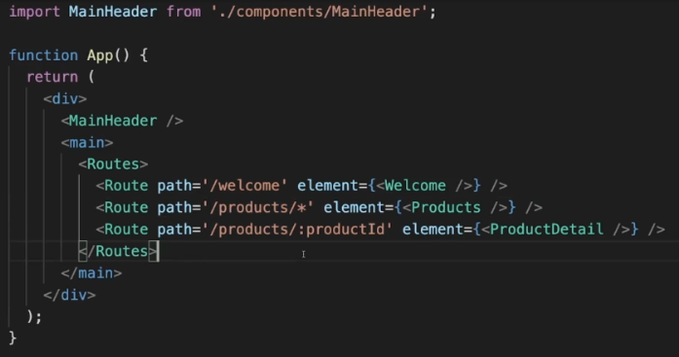

To show active NavLink in version 6 we use this function

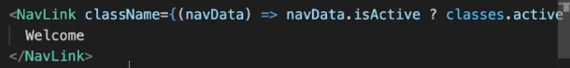

To Navigating we use <Navigate to=”/path”/> in version6 instead of Redirect



To render nested Route we use write inside parent Route.

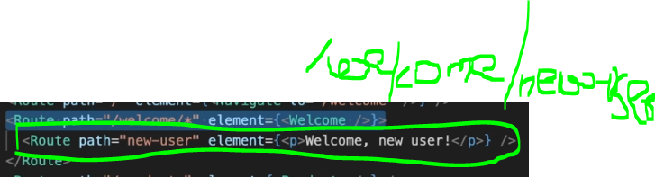In Order to render nested route in some position we use <Outlet /> there.

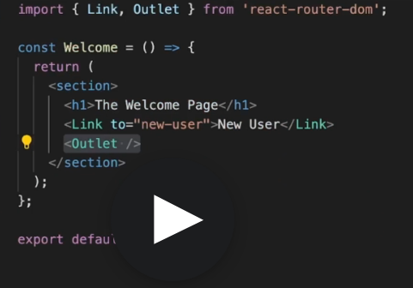

In version 6 we don’t have useHistory to navigate programitically we have useNavigate() hook.

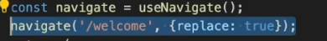

To prevent Navigation for unsaved Changes <Prompt/> will not work in version 6.

Lazy Loading:

Lazy Loading is Load code when its required.

When You visit any website, Javascript bundle for that website gets downloaded. So in order to prevent whole code of website to be downloaded we only download specific page code only where we visited.

As our website pages are splitted using Routes so we download code of specific route only when that page is visited.

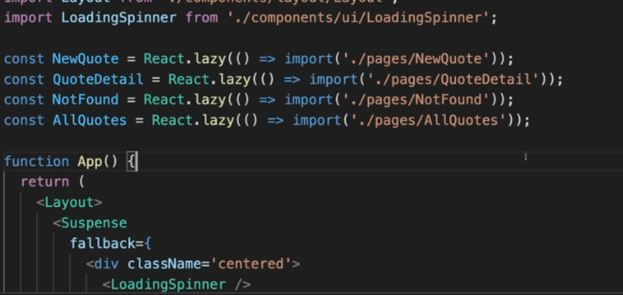

Next JS is the react Framework for production

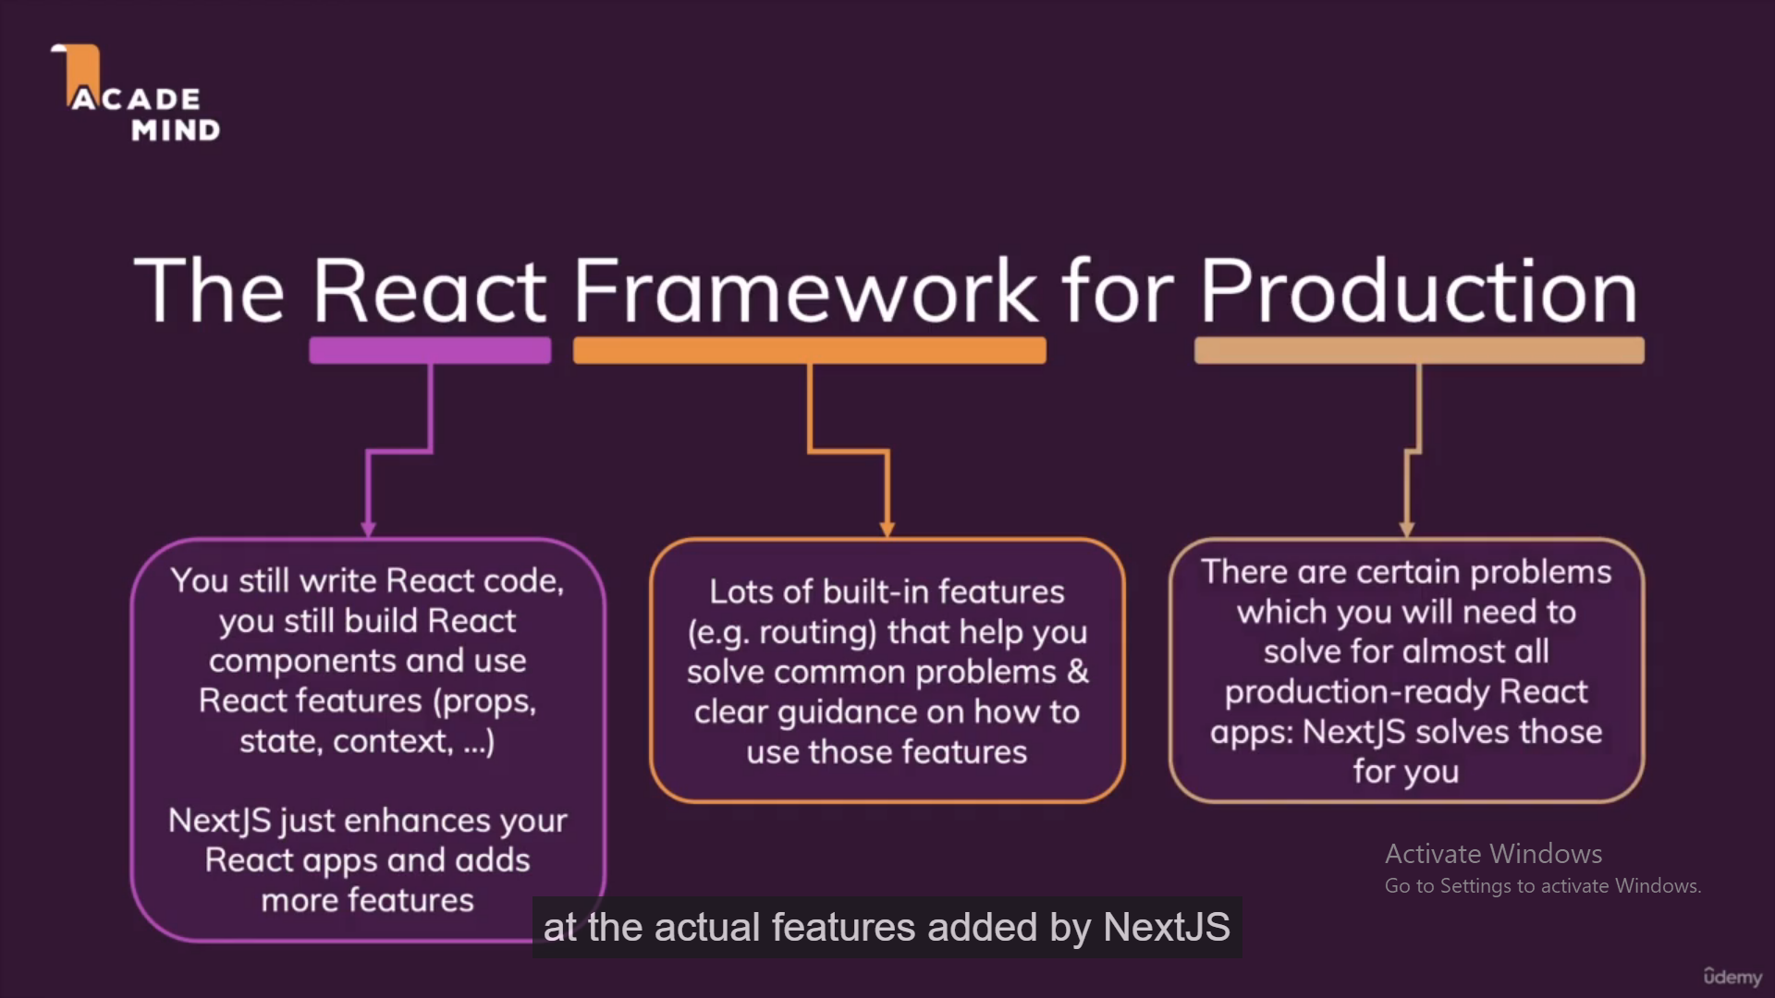

Lazy loaded module in Angular: only load module when only specific route is selected

Learn react Custom Hook,redux, useCallback hook

useCallback()-> when we don’t want to create function on Re-rendering , on change in some other state variable in component, it will return memoized callback function,which hold the last change state.

This helps us to maintain referential equality of the function when we pass that function to different components to prevent running that function unnecessary.

Refer. Web dev simplified video.